Invitation to the biggest Czech & Slovak automotive supplier matchmaking
We are pleased to invite your company and purchasers to the second edition of CEE Automotive Supply Chain 2018.
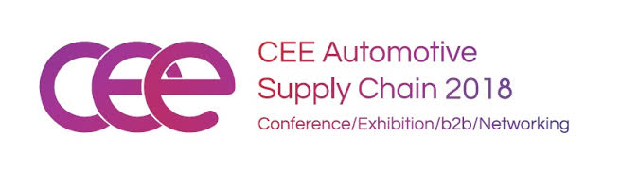
CEE Automotive Suppy Chain combines conference, exhibition, networking and organized B2B meetings.The event is designed for automotive suppliers & subcontractors and wasattended by 400 delegatesfrom 12 different countries last year.
Date: 23 & 24 OCTOBER 2018
Venue: X-BIONIC SPHERE & HOTEL****, Šamorín, Slovakia
Main organizers:
- Automotive Industry Association of the Czech Republic
- Automotive Industry Association of the Slovak Republic
- British Chamber of Commerce in the Slovak Republic
- French-Slovak Chamber of Commerce
- German-Slovak Chamber of Industry and Commerce
- Korea Trade-Investment Promotion Agency
These organizers are the guarantee of a high-quality conference program and a large number of members from all levels of the supply chain. Prior to the event, you can select partners for pre-planned B2B meetings where you can discuss the possibilities of developing your business relationships and services.
Take the opportunity to meet and establish cooperation with leading representatives of the automotive sector not only from V4 region.
Register for the event at: www.casc.sk (early bird tickets available until September 25th, 2018).
If you would like to become a partner of the event, please contact us at dvorscakova@casc.skfor more information about partnership opportunities.
We are looking forward to seeyou in Šamorín!

